PEARL EDU FUND (PEF) UGANDA

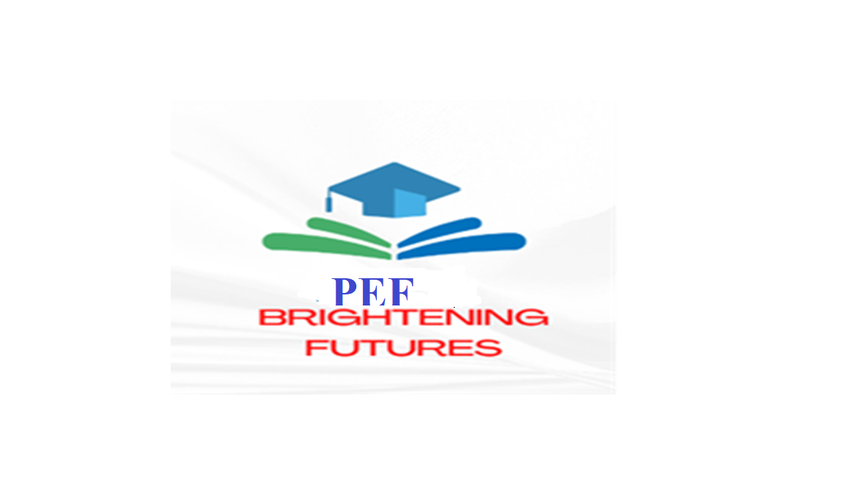
Submitted to:
Gayaza High School
Zirobwe,Gayaza

Prepared by ;

Ddamulira Aaron

Founder

St Mary’s College Kisubi,

P.o Box 26,

Email ; ddamuliraaaron648@gmail.com

ON BEHALF OF :

PEARL EDU FUND

EMAIL ; pefaug@gmail.com

Tel ; 0700800362

Submitted by :

DDAMULIRA AARON

0774607494
Ddamuliraaaron648@gmail.com
TABLE OF CONTENTS
COVER LETTER 2
SECTION I. ABOUT THE ASSOCIATION 3
Company Profile: 3
Vision: 3
Mission: 3
Values: 3
Strategy: 4
SECTION II: PROPOSED IDEA/ SOLUTION 5
Project description: 7
Problem Statement: 7
1.1. Project Goal: 7
Project Objectives: 7
Project Outcomes/Results: 7
Project Activities: 8
Risks and Mitigation Measures: 8
Consideration of Cross-Cutting Issues: 9
1.2. Equal Opportunities: 9
Co-operation with partners and Beneficiaries: 9
Potential for replication or scaling: 9
Monitoring, Evaluation & Reporting: 10

COVER LETTER

PEARL EDU FUND
ST MARY’S COLLEGE KISUBI,
P. O. BOX 26,
KISUBI.
KAMPALA, UGANDA
25th May,2024.
The Headteacher,
Gayaza High School,
Zirobwe,Gayaza.

Dear Sir/Madam,
Re: REQUEST TO INTRODUCE PEFA CLUB AND PEF PROGRAMME
Hello, Pearl Edu Fund Services is pleased to present this proposal for your review. We look forward to partnering with you to ensure equitable and quality education for the children of the non-teaching staffs in Uganda. Pearl Edu Fund. During the last years, we have been piloting the life that most non-teaching staffs lives go through and we found it miserable with most of their children unable to go to school because of funds. We are seeing measurable success and now we seek for financial assistance to expand the program to address the needs for these children.
We kindly hope for a positive reply. We will appreciate you taking interest in helping these children achieve their dream career. Please email us on pefaug@gmail.com in case you require any further information.
Yours faithfully,
Ddamulira Aaron
DDAMULIRA AARON
FOUNDER PEFA and PEF

SECTION I. ABOUT THE ASSOCIATION

Company Profile:

In the recent years of 2021 and 2022, there has been a growing number of children of non-teaching staff poised not to attend school at different levels due to lack of school fees resulting from low pay of their parents in most schools across Uganda. However, the growing concern of keeping the child in school for better communities and grooming responsible citizens is the key driver and reason as to why PEF-Uganda plans to expound its approach and strategy to finance access to quality education for millions of Ugandan children born to those that cannot afford the cost, with specific focus to non-teaching staff.

Vision:

To be the leading non-profit charity organization financing access to quality education for non-teaching staff children

Mission:
Our mission is to pursue excellence in providing quality education, bringing forth principled and improved livelihood for the children of non-teaching staffs.

Values:
Pearl Education Funding Services Uganda attaches much importance and value to the way management and staff conduct themselves; and how they serve the clients. In its drive to excellent service, Pearl Education Funding Services Uganda is guided by the following values;

Integrity: We demonstrate this by:
- Treating people with courtesy and respect
- Listening to what people have to say and responding helpfully
- Giving people the opportunity to use and develop their talents
- Valuing diversity.

Accountability We demonstrate this by:
- Being honest
- Being consistent both in what we do and say
- Taking responsibility for our actions and decisions

Collaboration We demonstrate this by:
- Wishing to learn from and share with other people
- Putting effective relationships at the heart of our work

- Working towards common goals.

Creativity We demonstrate this by:
- Encouraging people to develop new ideas in an environment of trust
- Being resourceful and innovative in our approach
- Actively seeking and presenting the best in creativity.

Professionalism We demonstrate this by:
- Being true to our values and keeping our promises
- Listening to and valuing the ideas and opinions of others
- Accepting individual and collective responsibility for delivering work to a high standard

Strategy:
Our strategy is to focus on easing access to education financing and livelihood improvement through savings and investment. We continuously seek innovative ways to enhance capacity of the non-teaching staff in accumulating savings and investing qualitatively, improve the quality of our services as well as monitoring all aspects of our business scope and its quality performance while addressing the needs of all our key stake holders. Finding possible ways of Providing scholastic materials and paying school fees dues.

SECTION II: PROPOSED IDEA/ SOLUTION
2.0. Background Information:
Quite often certain groups of people who play a big role in the life and protection of children at school are forgotten. These people are never thanked for the good work and service they do in helping and protecting children but rather abused, insulted, undermined, scorned and at worst brought to violence just for the smallest thing they have done. All this is done by either our parents or even their employers (the school head teachers and teachers at school). However, much as they try their level best to impress them by doing good, they will always look for the smallest bad things they have done.
This category of people includes; the cooks, security guards, wardens, matrons among others, who are always referred to as supportive or non-teaching staff. They undergo poor living conditions, they are in most cases undermined to the level that some are not paid and those who are paid, not in time or less. In our opinion, these people are humans like us and have their families to take care of and we do believe that they should be paid in time because what they are doing is not because they want but they were pushed by different circumstances and conditions.
Most times, even the little money they are paid, cannot sustain all their family and personal needs and in this case it is their children who suffer. They suffer in a way that they may not get all their basic needs in time most especially education. Different people, organizations, ministries and governments worldwide including us cannot agree with this anymore so have come up to give a helping hand.
Worldwide, the UN (United Nations) also fights for the rights of social workers. This is under the different organs like The Human Rights Council and the Office of the United Nations High Commissioner even the Committee on Economic Social and Cultural rights is part of this human rights in specific workers’ rights fight. In Africa, under the African Union is an organ called African commission human and people’s rights which fights for people’s rights. In Uganda, the human rights commission under the ministry of labor, gender and social development which fights for the rights of everyone in Uganda ranging from the young, youth, women, the labor force where people (non- teaching staffs) that we are striving to help belongs.
Rights of workers are not only fought in Uganda but also in different countries National Association for the Advancement of white people in South Africa, Ministry of Interior and Federalism and Ministry of National Security, women and human rights Development in Somalia. Different Individual organizations and NGO's have also embarked on the fight for human rights for example Amnesty International Children's Defense Fund, Human Rights Action Center, Human Rights Watch, Human Rights without Frontiers Simon Wiesenthal Centre among others.
As an organization, we want to differ so we looked for a different way of helping these workers especially the non-teaching staff. We are thinking since these people cannot take care of all their needs like medication, education for their children, we decided to help in the education of their children. We chose education so that these children can get their basic needs and enjoy normal life like others It will not only enable these children enjoy a normal life but also reduce on the level of illiteracy, levels of unemployment, poverty and also provide promote better living conditions for these children as they work hard towards pursing their intended career.
Some of the children being helped are youths so then getting education will help promote morals reducing on levels of juvenile delinquency. The money these non- teaching staff would have used to take these children to school can be used to develop themselves. Looking through all these advantages, they all look forward to the development of our country, Uganda.
According to the Education Statistical Abstract 2016, Uganda has 32729 non-teaching staff in secondary schools 61.4% males and 38.6% females. Making it males more than females by 22.8% complying that jobs in this sector are more adherable to males than females. The non-professional staff accounts the highest percentage (52.6%) followed by the pedagogical support (22.4%) and the rest administrative.

This project is also coming up to help the country in pushing up to a middle income country where an individual is able to afford at least a dollar a day so as to even address the united nations sustainable development goals of zero hunger and quality education.

Project description:
We propose to develop a unique and more affordable means of supporting children of non teaching staff through access to payment of some of their fees, low interest loans and affordable payments modes. Pre-term financing to ensure the child is at school on start date.

Problem Statement:
Whereas many organizations like the Uganda Human Rights Commission, Uganda National Teachers Union, many have paid much attention to teaching staff and heads of institutions and majority of the non-teaching staff have remained voiceless yet they are also exposed to the financial challenges that everyone faces.
Gap: As of today, it is not clear whether children of non-teaching staff can access quality education at good or the would be best schools in the country due to low pay and high costs associated with access to education and financing options.

Hook: The possibility of understanding if there exists some financing options to allow affordability of education on the side of non-teaching staff has to be addressed by friendly alternatives and this is what PEF-Uganda wishes to bring on board.

Objective: Our proposal is to identify the possible financing alternatives for children of non-teaching staff to access quality education.

  - Project Goal:
- Increasing access to quality education among children of non-teaching staff in Uganda.

Project Objectives:
- To enhance access to quality education among children of non-teaching staff
- Ensure children of non teaching staff have access to necessary educational resources and financial support to foster an inclusive and supportive environment for their academic success
- To reduce the burden of school fees among non-teaching staffs
- To prepare children of non-teaching staff for the best career in future
- To reduce school drop outs among children of non-teaching staff due to school fees
- Increase awareness among school community about the valuable contribution of non teaching staff

Project Outcomes/Results:
- Improved quality of lives of children of non-teaching staff as a result of accessing quality education.

- Improved standards of living among the children of non-teaching staff and their families

- Increased literacy levels

- Reduced school dropout rates

- Reduced prevalence of crime and societal insecurities.

Project Activities:
Our key activities will include;
- Data collection for all beneficiaries
- Status assessment to ascertain responsibility levels of non-teachin staff
- Hold consultative meeting with heads of schools and non-teaching staff
- Make a preliminary meeting with children and their parents (Non-teaching staff)
- Shortlist successful non-teaching staff and their children
- Draft and sign MoUs with respective academic institutions/Institutions
- Procurement of, and distribution of scholastic materials to selected children

Risks and Mitigation Measures:
Risk Identified | Mitigation Strategy | Responsibility
Theft of Funds | - Implement checks and Balances  - Practice proper Bookkeeping  - Monitor Transactions  - Count-Incount-Out Cash  - Conduct monthly Checks | Project Coordinator ,Board Treasure And Finance Officer
Fundraising Fraud | - Additional Oversight | M&E Officer
Reputational Damage | - Plan media Communication Strategy  - Strong internal Communication | Communication Officer
Directors And Officers Liability |  | Project Manager
Donor Data Breaches | - Limiting access to  Information
Special Events | - Proper Planning and Budgeting | Coordinators
School Dropouts | - Guidance and Counselling to  Dropouts | Coordinators & Board

Consideration of Cross-Cutting Issues:
  - Equal Opportunities:
- Without discrimination, the project will involve Youth, men and women, persons with disabilities, persons with HIV/AIDs, regardless of their gender, race, religion, and socioeconomic background.

- All the structures under this project will be disability friendly so that the right to access is granted to participants.

- The project will allow time for participants to reconcile work and family with guidance on proper time planning.

- Emphasis will be put on equalization of opportunities with equal access to finances, academic institutions
- The project will encourage girl and women participation across all processes.

- The project will operate with a child protection and an Adult safeguarding policy to mitigate risks around gender based violence and any form of discrimination during implementation.

- All project operations will be guided by the organization’s health, risk and socio-environmental safety policy.

Co-operation with partners and Beneficiaries:
- We will hold a meeting with all local and international partners and stakeholders to inform them about standards and expectations

- We will clarify the project objectives and expectations to project partners and beneficiaries at project start, during and after implementation.

Potential for replication or scaling:
Upon successful completion and execution in the four (4) districts of Kampala, Mukono, Jinja, and Wakiso, PEFA-Uganda will open up operating branches to extend similar services to beneficiaries of the same category across Uganda.

Monitoring, Evaluation & Reporting:
- Progress review meetings on a weekly and monthly basis will be conducted to track progress of project implementation.

- We will conduct perception surveys to establish the quality of services developed and areas for improvement during the execution.

- We plan to track progress using Results Based Monitoring tools like dashboards to establish the aftermath of resources, processes, outputs and outcomes of the project.

- We will engage Monitoring and evaluation experts to carry out evaluations assessments and analysis on performance, and progress trends on a quarterly and annual basis.

- We will continuously conduct SWOT analysis and Cost-Benefit analysis during and after project implementation.

- We will be preparing and sharing monthly project reports and end of project report with funders, rightful and relevant stakeholders.

CONCLUSION
The proposed project is an essential initiative aimed at empowering the children of non-teaching staff by enhancing their educational opportunities and outcomes. This project is not merely an educational support program; it is a comprehensive effort to uplift families and communities that have often been overlooked. By focusing on the children of non-teaching staff, we are addressing a critical need for equity in education, ensuring that these young individuals have access to the same opportunities as their peers, regardless of their family’s socio-economic status.

Education is the foundation upon which brighter futures are built, and by investing in these children’s education, we are investing in the long-term prosperity and well-being of our society. This project will provide much-needed resources such as academic tutoring, scholarships, and access to educational materials, all of which are crucial for these students to excel. More importantly, it will foster a sense of belonging and self-worth in these children, helping them to believe in their potential and pursue their dreams with confidence.

The impact of this initiative will resonate far beyond the immediate benefits to the children involved. By alleviating the educational burdens faced by non-teaching staff families, we are contributing to a more balanced and harmonious community. Parents will experience reduced financial stress and greater peace of mind, knowing that their children are receiving the support they need to succeed. This, in turn, strengthens the family unit, as parents and children alike feel more connected and supported in their educational journeys.

Furthermore, as these children achieve greater academic success, they will become role models within their communities, inspiring others to strive for excellence and pursue higher education. This can create a positive cycle of achievement and aspiration, where education becomes a shared value and a pathway to a better life. Communities that prioritize education are more resilient, cohesive, and capable of facing the challenges of the future.

On a broader scale, this project aligns with national goals of promoting education as a driver of social and economic development. An educated populace is key to fostering innovation, economic growth, and social progress. By supporting these children today, we are helping to cultivate the leaders, thinkers, and professionals of tomorrow who will contribute to the nation’s advancement. The benefits of this project will be felt not only by the families and communities directly involved but also by society as a whole, as we build a more inclusive and equitable future.

In conclusion, this project is a strategic and compassionate response to a pressing need in our society. By providing educational support to the children of non-teaching staff, we are making a powerful statement about the value of every child’s potential and the importance of equitable access to education. This initiative will have lasting benefits, empowering individuals, strengthening families, enriching communities, and contributing to the nation’s long-term growth and prosperity. We are confident that the success of this project will be a testament to the transformative power of education and the enduring impact of investing in our youth.

